GitHub link: <https://github.com/Sa22ahy/Vis_assignment>

The COVID-19 dataset available on the WHO website provides a useful resource to study the worldwide impact of the pandemic. It contains daily reports submitted to WHO with detailed records of new cases and deaths. The data includes important information like date, country codes, country names, WHO regional offices, confirmed new and total cases, confirmed new and total deaths. This allows comprehensive analysis of how the pandemic has progressed over time across different countries globally. Researchers, policy makers and analysts can use this data to understand COVID transmission patterns and mortality rates. They can also identify insights to inform evidence-based strategies for controlling the pandemic and responding to it effectively on a global scale. Overall, the standardized dataset enables detailed evaluation of the evolving COVID-19 situation across diverse countries and territories worldwide. I have used this dataset for my visualization assignment.

Dataset used from: <https://covid19.who.int/WHO-COVID-19-global-data.csv>

Visualization 1: Pie Chart

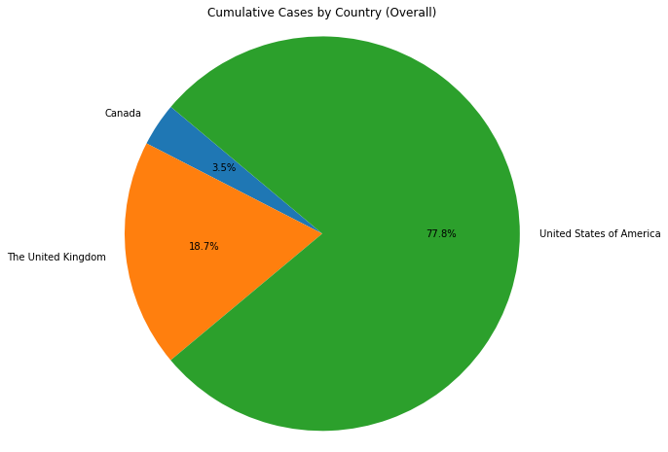

A pie chart is a type of graph that shows the relative sizes of different categories of data. It is a circular graph divided into slices, with each slice representing a category. The size of each slice is proportional to the category's percentage of the total.

The pie chart shows the cumulative cases of COVID-19 by country, as of 2023.

The United States of America has the highest number of cumulative cases, with 77.8% of the total. Canada is second with 18.7%, and the United Kingdom is third with 3.5%.

This means that the United States has nearly 8 out of every 10 COVID-19 cases in the world, while Canada has about 2 out of every 10 cases, and the United Kingdom has about 3 out of every 100 cases.

Visualization 2: Bar Chart

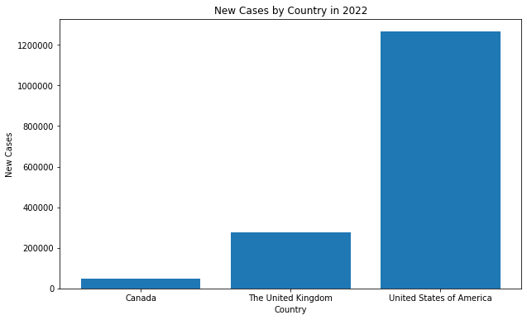

A bar chart is a type of graph that shows the distribution of data by category. It consists of vertical or horizontal bars, with the length of each bar representing the value of the category. Bar charts are useful for comparing different categories of data, or for showing how a category has changed over time.

The provided bar chart illustrates the total number of new COVID-19 cases reported in the year 2022 across three countries - the United States, Canada, and the United Kingdom. Of the three, the United States registered the highest number of new cases in 2022 with over 1 million reported cases. This indicates a significantly larger disease burden compared to the other two countries. Canada recorded the second highest number with over 600,000 new cases during the same period. The United Kingdom registered the lowest number of the three countries with over 400,000 new cases in 2022, still representing a substantial disease impact. In summary, the United States led with more than double the number of new COVID cases in 2022 compared to Canada, while the UK trailed significantly behind the North American nations with around 60% fewer cases than Canada. The data provides valuable insights into the progression of the COVID-19 pandemic across these major countries in the past year, highlighting the continued pressure and health system challenges imposed by the disease. Monitoring such trends can inform public health measures and policy decisions to control viral transmission and mitigate the pandemic's effects going forward.

Visualization 3: Line Chart

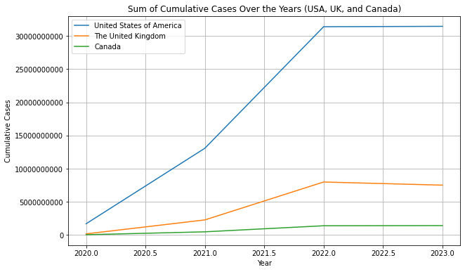

Line chart in one line: A line chart is a graph that shows how a variable changes over time, by connecting points with line segments.

The line graph depicts the total number of reported COVID-19 cases accumulated over time in three countries – the United States, the United Kingdom, and Canada. Throughout the pandemic, the United States has registered the highest count of cumulative cases, reflecting the immense disease burden it has endured. The curve for the U.S. shows a steady rise in total cases, indicating sustained viral transmission, although the rate of growth has slowed down in recent months. The U.K. follows behind with the second highest tally of cumulative cases, also displaying a persistent increase but at a comparatively moderate pace. Canada has recorded the lowest total case count of the three nations, but the curve still exhibits a gradual incline highlighting continued disease spread. While all three countries exhibit rising cumulative case trends, the growth rate has decelerated in the past few months as compared to earlier phases of rapid exponential increase. Monitoring the cumulative data offers key longitudinal insights into the COVID-19 situation and the varying degrees of public health impact in these major countries. Comparing the infection curves can inform policy decisions regarding pandemic response and control measures.

GitHub link: <https://github.com/Sa22ahy/Vis_assignment>